|  |  |
| --- | --- |
| Leasing and Integrated Accounting System | Software Requirement Specification |
| **Version: 1.0**  **Owner: Ethics Advanced Technology Limited**  **Date:01/11/2014** | |

Revision History

|  |  |  |  |
| --- | --- | --- | --- |
| Doc. Ver. | Date | Author | Description of Revision |
| V 1.0 | 22/10/2014 | EATL | SRS 1.0 |
|  |  |  |  |
|  |  |  |  |
|  |  |  |  |

Contents

1. Introduction 4

1.1 Purpose 4

1.2 Scope 4

1.3 Audience Description 4

1.4 References 4

1.5 Definitions, Acronyms, and Abbreviations 4

2. Overall Description 5

2.1 Overview 5

2.2 Target platform 5

3. Functional Requirements 5

3.1 Overview 5

3.2 Feature/Function 1 5

3.3 Feature/Function 2 6

3.4 Feature/Function 3 6

3.5 Feature/Function 4 7

4. Non-Functional Requirements 7

4.1 Performance Requirements 7

4.2 Design Constraints 7

4.3 Safety Requirements 8

4.4 Security Requirements 8

4.5 Software Quality Attributes 9

5. Other Requirements 9

1. Introduction

The introduction of the Software Requirements Specification (SRS) provides an overview of the entire SRS with purpose, scope, definitions, acronyms, abbreviations, references and overview of the SRS. The aim of this document is to gather and analyze and give an in-depth insight of the complete **Leasing and Integrated accounting software System by** defining the problem statement in detail. Nevertheless, it also concentrates on the capabilities required by stakeholders and their needs while defining high-level product features. The detailed requirements of the **Leasing and Integrated Accounting** are provided in this document.

* 1. Purpose

The purpose of the document is to collect and analyze all assorted ideas that have come up to define the system, its requirements with respect to consumers. Also, we shall predict and sort out how we hope this product will be used in order to gain a better understanding of the project, outline concepts that may be developed later, and document ideas that are being considered, but may be discarded as the product develops. In short, the purpose of this SRS document is to provide a detailed overview of our software product, its parameters and goals. This document describes the project's target audience and its user interface, hardware and software requirements. It defines how our client, team and audience see the product and its functionality. Nonetheless, it helps any designer and developer to assist in software delivery lifecycle (SDLC) processes.

* 1. Scope

The system is composed to Web application which is browser Independent developed by Microsoft Visual Studio 2010. The system is designed to facilitate the process of tracking inventory material, transfer to others branch, maintains inventory stock for head office and

Branch, solar leasing system, maintains installment process of customers and also maintains financial accounting system etc.

* 1. Intended Stakeholder

EATL Project Team, Board of Director of ZH Group, MD of Meghna Solar, All branches Manager, Head office Accounts Manager Head Office GM are consider as Stakeholder of this Project.

Reference Document



* 1. References

All references listed in this table are for EATL Usage only.

|  |  |
| --- | --- |
| Reference | Location |
| Meghna-Solar_StakeHolder |  |
| Requirement Traceability Matrix |  |
|  |  |

* 1. Definitions, Acronyms, and Abbreviations

|  |  |
| --- | --- |
| Term/Acronym | Definition |
| ASP | A server side scripting language used by .Net |
| SQL | Data Base that will be used for this project |
| JQuery | A client scripting Language |
| CR | Crystal Report that is used for Reporting |

All non-standard terms, acronyms and abbreviations that are unique to this document should be included in this section. References to other appendices or reference documents may be included. Index information should be in bold.

* **IEEE** – Institute of Electrical and Electronics Engineers
* **SRS** – System Requirements Specification
* **PRD** – Product Requirements Document
* **MRD** – Marketing Requirements Document

Also see IEEE Std 1002-1987, IEEE Standard Taxonomy for Software Engineering Standards.

1. Overall Description
2. Overview

This document contains the problem statement that the current system is facing which is hampering the growth opportunities of the company. It further contains a list of the stakeholders and users of the proposed solution. It also illustrates the needs and wants of the stakeholders that were identified in the brainstorming exercise as part of the requirements workshop. It further lists and briefly describes the major features and a brief description of each of the proposed system. It provides the detail product functions of E-Store with user characteristics permitted constraints, assumptions and dependencies and requirements subsets.

**Product perspective**

The **Leasing and integrated Accounting System** project is a new, self-contained product intended for use on the Microsoft Visual Studio .Net platform. While this application is the main focus of the project, there is also a server-side component which will be responsible for database and synchronization services. The scope of the project encompasses both server- and client-side functionalities, so both aspects are covered in detail within this document. Below is a diagram of this system which illustrates the interactions between the server and client applications.

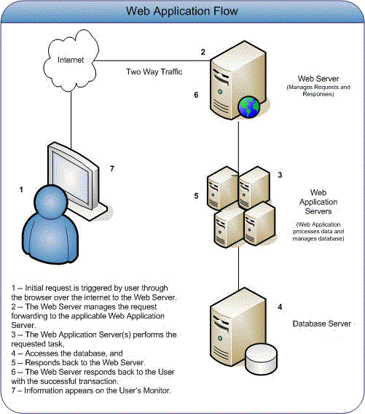

Fig 01: Megna Solar System Web Application Flow

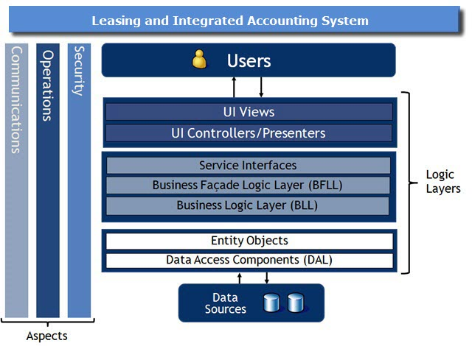

Fig: 02 Solution Architecture Diagram

**Product functions**

The following list offers a brief outline and description of the main features and functionalities of the Leasing and Integrated Accounting system.

|  |  |  |
| --- | --- | --- |
| **Sl. no.** | **Items** | **Summary** |
| 1 | General Configuration | General Configuration is the major part of **Leasing & Integrated Accounting System**. This system provide the integrated solution for keeping track of the company information and it’s a one way process for setup the company rules and regulation. It includes all branches as well.  Features:   1. Company Information 2. Branch Information (Multiple Branch maintenance by one database) 3. Define Accounting Method 4. Define Accounts Posting Method 5. Setting Accounting Period 6. Cards    1. Customer Information    2. Vendors/Supplier Information. 7. Analyzing Business Rules. |
| 2 | Integrated Accounting System | It automatically prepares the financial Statement like Cash Book, Bank Book, Ledger, Balance Sheet, Trial Balance, Profit and Loss, Budgeting and analysis etc.  Features:   1. Preparing Chart of Accounts as Branch wise 2. Control & Ledger Accounts Creation (Ledger/Group Control Account) 3. Define Cash & Bank Account 4. Define Accounts Receivable, Accounts Payable 5. Define Purchase Accounts 6. Define Sell Accounts 7. Define Bank Account Information 8. Bank Accounts Link to Chart of accounts 9. Cheque Book and Cheque Leaf Information 10. Prepare Payment, Receipt and Journal Voucher. 11. Voucher Posting 12. Define Fiscal Year   Reports:   1. Chart of Accounts List 2. Transaction History 3. Journal, Ledger, Balance Sheet, Trial Balance Statements 4. Cash & Bank Book Statements 5. Voucher Entry Report 6. Accounts Receivable and Accounts Payable Statements 7. Profit and Loss statement |
| 3 | Leasing Management | Leasing Management is important part of **Leasing & Integrated Accounting System** this system manages their leased, tracking of customer ledger and sales collection history.    Features:   1. Leasing agreement system 2. Customer Ledger maintain 3. Monthly collection   Reports:   1. Leasing agreement sheet 2. Customer Ledger 3. Monthly sales collection |
| 4 | Security Management | 1. Group Creation, Deletion and Updating with change password, termination option 2. User Creation, Deletion and Updating with change password, termination option 3. Providing Permission Group and user basis |
| 5 | Employee Management | Employee Transfer Log  Employee Management |
| 6 | Inventory Management | An efficient inventory management system rapidly responds to customer requirements and it is flexible enough to undertake any corrections when required. It does so without adversely affecting operational efficiencies. The Inventory Management module offers effective features to minimize warehousing costs and to optimize storage needs in line with the requirements in hand.  Features:   1. Opening Stock 2. Receiving Process 3. Head office Receiving Process 4. Disbursement Tracking 5. Transfer Tracking 6. Closing Inventory Status 7. Current Stock Status 8. Date wise stock Status, etc.   Reports:   1. Opening Stock Report 2. Closing Balance Report |

**User characteristics**

The Leasing and Integrated Accounting project is meant to offer a shared expenses solution that is faster, easier, and more convenient than manually calculating and handling debts. Consequently, the application will have little or no learning curve, and the user interface will be as intuitive as possible. Thus, technical expertise and .Net experience should not be an issue. Instead, anticipated users can be defined by how they will use the product in a particular situation. The following list categorizes the scenarios in which Meghna Solar is expected to be utilized

1. Long-term recurring expenses (e.g. leasing)
   * + - Key functions:

Keep track of Installment

Notify users when debts are incurred

Record who has paid and who still owes

* + - * Requirements:

Method for inputting installment into the application

Support for automated notifications

Database containing current debts, past transactions, etc.

1. Short-term recurring expenses (e.g. official costs)
   * + - Key functions:

Add new expenses (quickly and easily)

Record who is paying and what he/she is paying for

Update Ledger balances

* + - * Requirements:

Simple and intuitive user interface for adding expenses

Voucher-tracking system

Automated, background algorithm for calculating Ledger

**Constraints**

* Handle large volume data
* High bandwidth Internet requirement
* Platform dependent
* Due to change Management requirement may change
* Synchronize Accounts to Inventory and Leasing data

**Assumptions and dependencies**

* It is assumed that the system will be developed using the ASP.NET technology.
* It is assumed that the system will interface with a SQL Server 2008 R2 database.
* It is assumed that organizations Provide good bandwidth Internet with Real IP.
* It is assumed that organizations provide windows Hosting system with goods space.

1. Target platform

* Application server
* Database Server ,SQL Server 2008 R2
* Crystal report 13
* Microsoft Visual Studio 2010
* Java Script, Jquery , HTML

1. Functional Requirements
2. Overview

|  |  |  |
| --- | --- | --- |
| Serial No | Main Functions | Description |
| 01 | General Configuration | This is the basic setting in this Project such as Company information, Employee Information .Product Setup ,Branch ,Area etc. |
| 02 | Inventory Management | Maintains Head office Inventory Stock , Branch Office stock, Tracking system for Inventory material challan, Collection efficiency, Recovery Rate, Advance and Partial collection, Installment collection etc. |
| 03 | Leasing Creation and Installment Tracking | Leasing agreement system, Customer Ledger maintain, Monthly collection Process etc |
| 04 | Accounting Management System | Chart of Accounts List, Transaction History , Journal, Ledger, Balance Sheet, Trial Balance Statements etc. |
| 05 | Employee Management | Employee Management, Employee Transfer Log |
| 06 | Security Management | Group Creation, Deletion and Updating with change password, termination option, User Creation, Deletion and Updating with change password, termination option etc. |

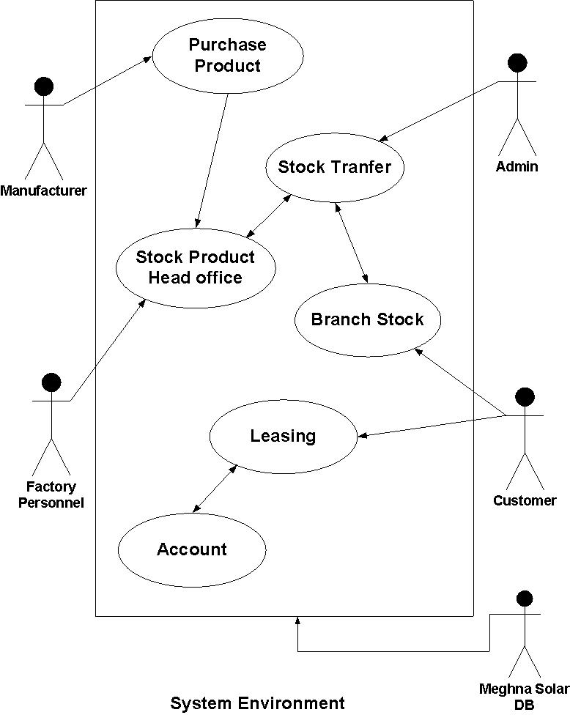

Fig 01: Use case for System Environment

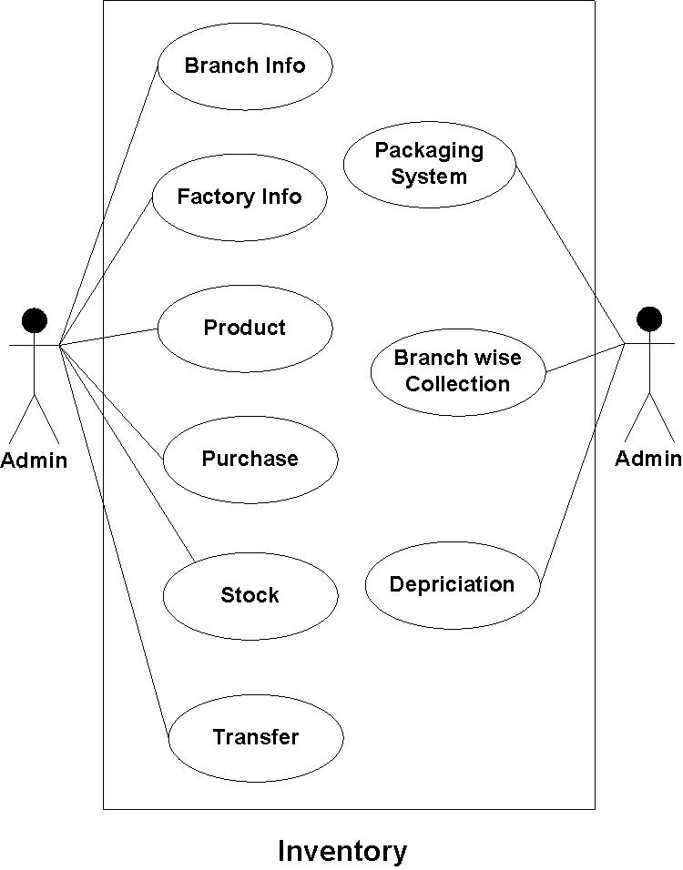

Fig 02: Use case for Inventory Management

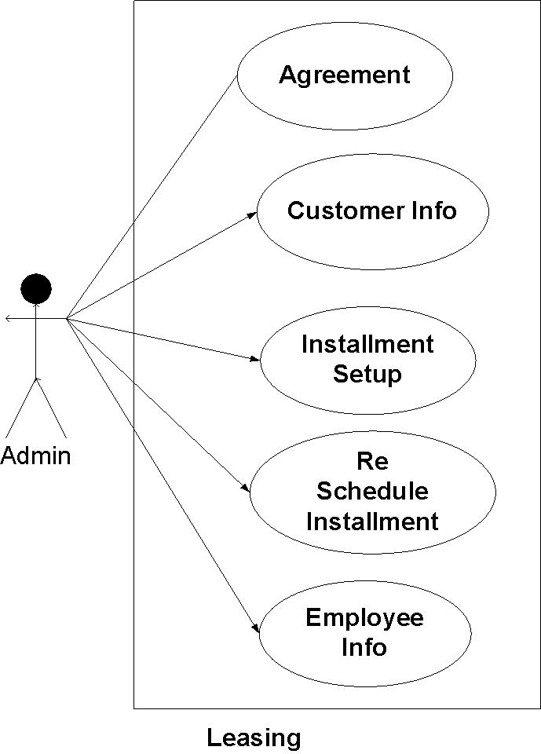

Fig 03: Use case for Leasing Management

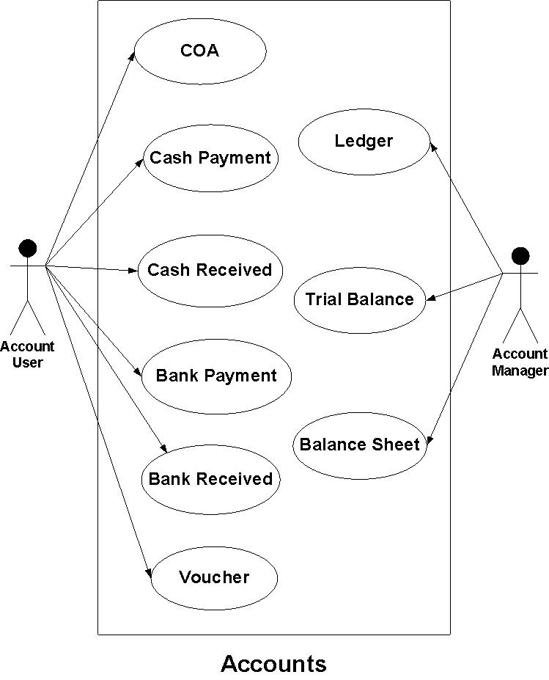

Fig 04: Use case for Accounts Management

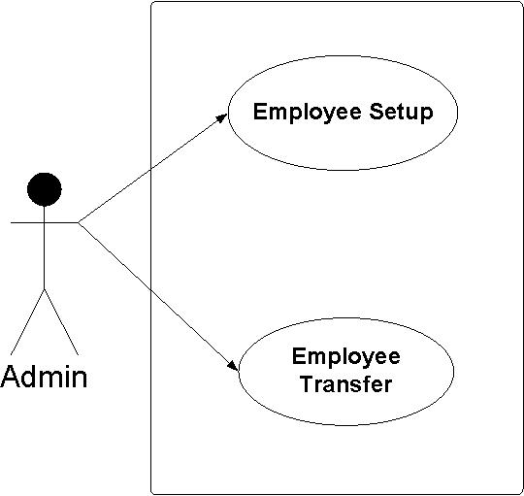

Fig 05: Use case for Employee Management

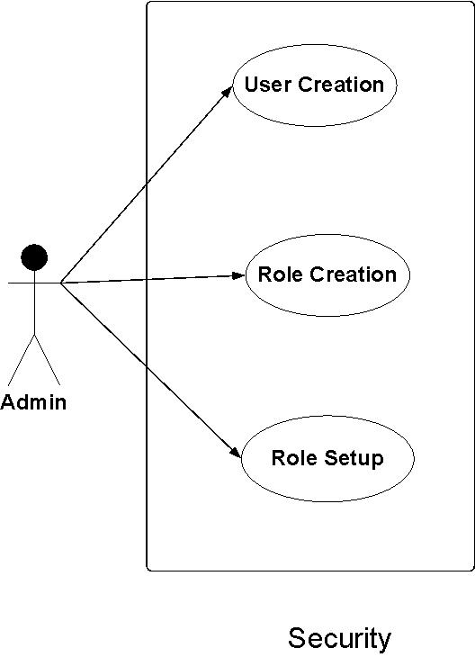

Fig 06: Use case for Security Management

1. General Configuration

###### Requirements

|  |  |  |  |  |  |  |
| --- | --- | --- | --- | --- | --- | --- |
| MRD No | REQUIREMNT Identifier | Requirement Text / DATA | Acceptability | Limitations | Notes | Test case Identifier |
| 01 | 3.2.1 | Company Group Setup | All company group entry | Company group serial Number maintainer |  |  |
| 02 | 3.2.2 | Company Setup | Company Information setup |  |  |  |
| 03 | 3.2.3 | Factory Setup | Factory Information Setup | Factory code needed |  |  |
| 04 | 3.2.4 | Branch Setup | Branch Information Setup | Serial code maintains |  |  |
| 05 | 3.2.5 | Region Setup | Region Information Setup | Serial code maintains |  |  |
| 06 | 3.2.6 | Area Setup | Area Information Setup | Serial code maintains |  |  |

1. Employee Management

###### Requirements

|  |  |  |  |  |  |  |
| --- | --- | --- | --- | --- | --- | --- |
| MRD No | REQUIREMNT Identifier | Requirement Text / DATA | Acceptability | Limitations | Notes | Test case Identifier |
| 01 | 3.3.1 | Employee Information Setup | Employee Information, Education setup | Employee code maintains |  |  |
| 02 | 3.3.2 | Employee Transfer Tracking System | Employee Transfer log | Date Tracking |  |  |
|  |  |  |  |  |  |  |

1. Inventory Management

###### Requirements

|  |  |  |  |  |  |  |
| --- | --- | --- | --- | --- | --- | --- |
| MRD No | REQUIREMNT Identifier | Requirement Text / DATA | Acceptability | Limitations | Notes | Test case Identifier |
| 1 | 3.4.1 | Product Type Setup | Master Product type Setup | Code Maintains |  |  |
| 2 | 3.4.2 | Product Master Setup | Master Inventory Setup | Code Maintains |  |  |
| 3 | 3.4.3 | Product Detail setup | Product Details Information | No Duplicate Product Code |  |  |
| 4 | 3.4.4 | Package Specification | Package Specification Information setup | No Duplicate Pacakage Code |  |  |
| 5 | 3.4.5 | Inventory Head office | Factory to Head office inventory setup | Date and Qty |  |  |
| 6 | 3.4.6 | Delivery Challan | Deliver Package to other branch | Date and Qty |  |  |
| 7 | 3.4.7 | Inventory Stock Maintains | Maintaince Inventory | Date and Qty |  |  |
| 8 | 3.4.8 | Received Challan Branch wise | Received Inventory Challan | Date and Qty |  |  |

1. Leasing

###### Requirements

|  |  |  |  |  |  |  |
| --- | --- | --- | --- | --- | --- | --- |
| MRD No | REQUIREMNT Identifier | Requirement Text / DATA | Acceptability | Limitations | Notes | Test case Identifier |
| 01 | 3.5.1 | New Leasing Creation | Leasing information, Customer information, Service charge, down payment | Leasing Number tracking,  Payment condition |  |  |
| 02 | 3.5.1 | Installment Collection | Calculate Installment |  |  |  |
| 03 | 3.5.1 | Sales Return with depreciation | Track Sales return information |  |  |  |
| 04 | 3.5.1 | Spare part sales | Spare part sales Information |  |  |  |
| 05 | 3.5.1 | Integration to Accounting | Data insert to Accounting while installment collection |  |  |  |

1. Financial Accounting

###### Requirements

|  |  |  |  |  |  |  |
| --- | --- | --- | --- | --- | --- | --- |
| MRD No | REQUIREMNT Identifier | Requirement Text / DATA | Acceptability | Limitations | Notes | Test case Identifier |
| 1 | 3.6.1 | COA ,Voucher Transaction Entry From | Voucher code, Date |  |  |  |
| 2 | 3.6.2 | Ledger | Maintaince Control account Ledger |  |  |  |
| 3 | 3.6.3 | Trail balance, Balance Sheet | Calculate and View Trail balance |  |  |  |

1. Non-Functional Requirements
2. Performance Requirements

**PERFORMANCE REQUIREMENTS**

Performance should not be an issue because all of our server queries involve small pieces of data. Changing screens will require very little computation and thus will occur very quickly. Server updates should only take a few seconds as long as the phone can maintain a steady signal. The cost-division algorithms used by in application will be highly efficient, taking only a fraction of a second to compute.

|  |  |  |  |  |  |  |
| --- | --- | --- | --- | --- | --- | --- |
| MRD No | REQUIREMNT Identifier | Requirement Text / DATA | Acceptability | Limitations | Notes | Test case Identifier |
| 1 | 4.1.1 | All report loading from server response time should me limit | Avg. 10 to 15 Sec | For a big data need high band with |  |  |
| 2 | 4.1.2 | Account Transaction and Leasing Installment collection posting |  | need high band with |  |  |

1. Design Constraints

|  |  |  |  |  |  |  |
| --- | --- | --- | --- | --- | --- | --- |
| MRD No | REQUIREMNT Identifier | Requirement Text / DATA | Acceptability | Limitations | Notes | Test case Identifier |
| 1 | 4.2.1 | The client component of the system needs to be accessible on multiple platforms and from remote locations. | UAT | Technical |  |  |
| 2 | 4.2.2 | Dealing large transaction so each feature must be designed and implemented with efficiency in mind | UAT | Technical |  |  |

1. Safety Requirements

|  |  |  |  |  |  |  |
| --- | --- | --- | --- | --- | --- | --- |
| MRD No | REQUIREMNT Identifier | Requirement Text / DATA | Acceptability | Limitations | Notes | Test case Identifier |
| 1 | 4.3.1 | Daily Source code backup by TL | Source back up log |  |  |  |
| 2 | 4.3.2 | Production Data Base Server back ip by Meghna Solar | DB Back up log |  |  |  |
| 3 | 4.3.3 | Development server backup | DB Back up log |  |  |  |

1. Security Requirements

|  |  |  |  |  |  |  |
| --- | --- | --- | --- | --- | --- | --- |
| MRD No | REQUIREMNT Identifier | Requirement Text / DATA | Acceptability | Limitations | Notes | Test case Identifier |
| 1 | 4.4.1 | * The system shall only allow unauthorized users to access the login, lost password, and registration page. | Page Security |  |  |  |
| 2 | 4.4.2 | * The system shall require a login and password to gain access to the site. | Page Security |  |  |  |
| 3 | 4.4.3 | * The system will track Deleted and Updated data * The system wills permission to pages for individual access and individual operation of pages. | Meghna Solar Data Back up |  |  |  |

1. Software Quality Attributes

|  |  |  |  |  |  |  |
| --- | --- | --- | --- | --- | --- | --- |
| MRD No | REQUIREMNT Identifier | Requirement Text / DATA | Acceptability | Limitations | Notes | Test case Identifier |
| 1 | 4.5.1 | The graphical user interface of this Project is to be designed with usability as the first priority. | UAT |  |  |  |
| 2 | 4.5.2 | The application will be presented and organized in a manner that is both visually appealing and easy for the user to navigate | UAT |  |  |  |
| 3 | 4.5.3 | Change Management and No deployment with out Testing | Verification |  |  |  |
| 4 | 4.5.4 | To ensure reliability and correctness, there will be zero tolerance for errors in the algorithm that computes and splits expenses between group members. |  |  |  |  |

1. Other Requirements

|  |  |  |  |  |  |  |
| --- | --- | --- | --- | --- | --- | --- |
| MRD No | REQUIREMNT Identifier | Requirement Text / DATA | Acceptability | Limitations | Notes | Test case Identifier |
| 1 | 5.1 | User manual | TL’s Appraisal |  |  |  |
| 2 | 5.2 | Technical manual | TL’s Appraisal |  |  |  |
| 3 | 5.3 | Create in FQA | Verification |  |  |  |

This section defines any other requirements not covered elsewhere in the SRS. This might include database requirements, budget requirements, schedule requirements internationalization requirements, legal requirements and so on. Feel free to add any new sections that are pertinent to the project.

This section specifies those requirements that are concerned with possible loss, damage, or harm that could result from the use of the sub-system. It defines any safeguards or actions that must be taken, as well as actions that must be prevented. Refer to any external policies or regulations that state safety issues that affect the sub-system design or use. Define any safety certifications that must be satisfied.